**Numericals: [5+5+10 = 20]**

**Question 1:** We observe an increase in the total delay (time) for those requests that encounter a web cache (a penalty because of the involvement of the cache). Let LD be the average LAN delay, ALD be the access link delay, ID be the Internet delay, and RT be the total response time. Moreover, assume that ACP is the average cache penalty delay. The following values are given LD = 10ms, ALD = 50ms, ID = 100ms, and ACP = X+ ms. Considering the above scenario and given values, answer the following questions:

1. Find the average response time, TR, without use of cache?

No cache: average response time = TR = LD + ALD + ID, thus RT = 10 + 50 + 100 = 160ms

1. Find the average response delay (time) when a cache is used and the hit ratio is 80%?

RT = Cache and hit time + Cache and miss time

RT = [0.8 * (LD + ACP)] + [0.2 * (LD+ALD+ID+ACP)]

ACP for my roll no in 5+2+7+3=17ms

RT = [0.8 * (10 + 17)] + [0.2 * (10 + 50 + 100 + 17] = 0.8 × 27 + 0.2 × 177

= 21.6 ms+ 35.4ms = 57 ms

[2.5 + 2.5 = 5]

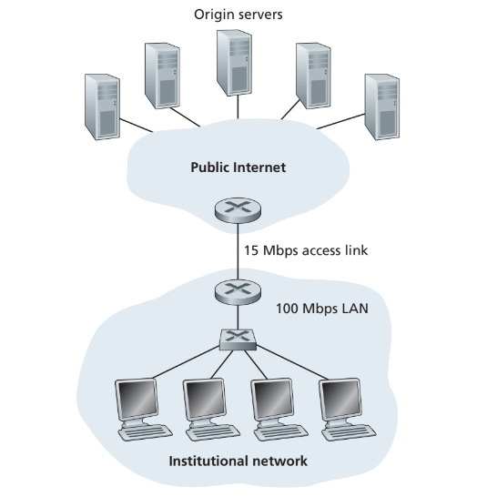

**Question 2:** Consider Figure 2.12, for which there is an institutional network connected to the Internet. Suppose that the average object size is XXXX,000 bits and that the average request rate from the institution’s browsers to the origin servers is 16 requests per second. Also suppose that the amount of time it takes from when the router on the Internet side of the access link forwards an HTTP request until it receives the response is three seconds on average (see Section 2.2.5). Model the total average response time as the sum of the average access delay (that is, the delay from Internet router to institution router) and the average Internet delay. For the average access delay, use Δ/(1 – Δ), where Δ is the average time required to send an object over the access link and is the arrival rate of objects to the access link.

a. Find the total average response time.

The time to transmit an object of size L over a link or rate R is L/R. The average time is the average size of the object divided by R:

Δ = (5273,000 bits)/(15,000,000 bits/sec)= 0.35 sec

The traffic intensity on the link is given by (16 requests/sec) (0.35 sec/request) = 5.6. Thus, the average access delay is (.35 sec)/(1-5.6)= -0.076 seconds. The total average response time is therefore -0.076 sec + 3 sec = 2.92 sec.

b. Now suppose a cache is installed in the institutional LAN. Suppose the miss rate is (X+)/100. Find the total response time.

Miss rate for my roll no is 17/100=1.7

The traffic intensity on the access link is reduced by 83% since the 60% of the requests are satisfied within the institutional network. Thus the average access delay is (0.35 sec)/[1-(.17)(5.6)]=7.29 seconds. the average response time is 7.29 sec + 3 sec= 10.29 sec for cache misses (which happens 17% of the time). So the average response time is (.83)(0 sec) + (.4)(10.29 sec) = 4.116 seconds

[2.5 + 2.5 = 5]

**Question 3:** Consider a short, 10m link, over which a sender can transmit at a rate of 150 bits/sec in both directions. Suppose that packets containing data are 100,000 bits long, and packets containing only control (e.g., ACK or handshaking) are 200 bits long. Assume that N parallel connections each get 1/N of the link bandwidth. Now consider the HTTP protocol, and suppose that each downloaded object is 100K bits long, and that the initial downloaded object contains 10 referenced objects from the same sender. Answer the following:

Note that each downloaded object can be completely put into one data packet. Let Tp denote the one-way propagation delay between the client and the server.

1. Calculate the time it takes to download all the objects via parallel non-persistent HTTP instances.

(200/150+Tp + 200/150 +Tp + 200/150+Tp + 100,000/150+ Tp ) + (200/(150/10)+Tp + 200/(150/10) +Tp + 200/(150/10)+Tp + 100,000/(150/10)+ Tp )

= 7377 + 8*Tp (seconds)

1. Calculate the time it takes to download all the objects via parallel persistent HTTP

(200/150+Tp + 200/150 +Tp + 200/150+Tp +100,000/150+Tp)+(200/(150/10)+Tp + 100,000/(150/10)+ Tp )

= 7350 + 6*Tp (seconds)

1. Calculate the time it takes to download all the objects via non-parallel persistent HTTP.

(200/150+Tp + 200/150 +Tp + 200/150+Tp + 100,000/150+ Tp ) + 10*(200/150+Tp + 100,000/150+ Tp )

=7351 + 24*Tp (seconds)

1. Would parallel downloads via parallel instances of non-persistent HTTP make sense in this case? Justify your choice.

Assuming the speed of light is 300*10^6 m/sec, then Tp=10/(300*10^6 )=0.03 microsec. Tp is therefore negligible compared with transmission delay.

Thus, we see that persistent HTTP is not significantly faster (less than 1 percent) than the non-persistent case with parallel download.

Yes parallel downloads via parallel instances of non-persistent HTTP makes sense in this case.

1. Do you expect significant gains from non-persistent parallel HTTP connections over the non-parallel persistent case? Justify.

we see that non-parallel persistent HTTP is not significantly faster (less than 1 percent) than the non-persistent case with parallel download.

[2+2+2+2+2=10]

**Question 4:** An Internet user located in Lahore requests a 125 KB web page from a server located in Islamabad. The received page references 5 image files, 250 KB each. User is connected to the Internet via a 10 Mbps access link. Assume that it takes 50 ms for a small HTTP message to travel from client to server (and vice versa).

1. What is RTT? Calculate the value of RTT in this above connection.

RTT is the round trip time taken for an HTTP message to reach the server and back. RTT = (50 ms) x 2 = 100 ms

1. Calculate the total time taken for the web page (including image files) to display on user’s screen if non-persistent HTTP is used with one connection at a time (ignore processing delays)

Web page: (2 x 100 ms) + (125 x 8 x 1000/10000000) = 300 ms

Image files: 5 x [(2 x 100 ms) + (250 x 8 x 1000/10000000)] = 2000 ms

Total time = 2.3 seconds

1. How long would it take to display the same web page with persistent HTTP (single connection)?

Web page: (2 x 100 ms) + (125 x 8 x 1000/10000000) = 300 ms

Image files: 5 x(100 ms + (250 x 8 x 1000/10000000)) = 1500 ms i.e there is no need for connection but 1RTT is required for request for each file

Total time = 1.8 seconds

[1+2+2 = 5]

**Descriptive Questions:**

**Question 5s:** Consider the following string of ASCII characters that were captured by Wireshark when the browser sent an HTTP GET message (i.e., this the actual content of an HTTP GET message). Answer the following questions.

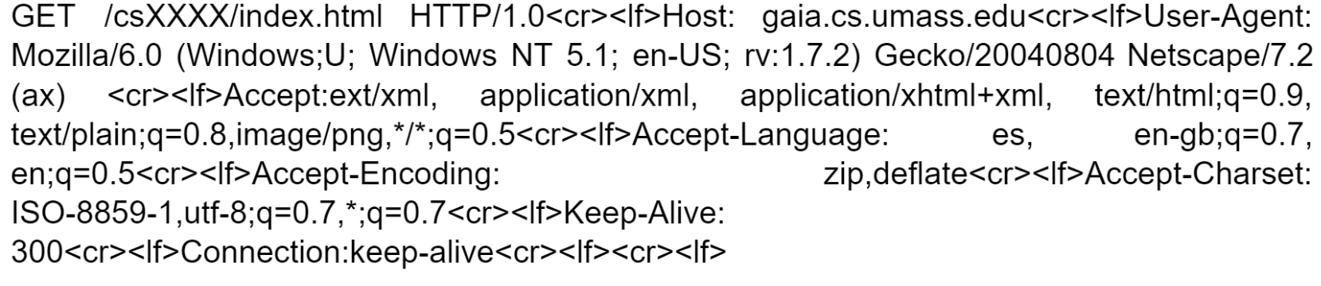

a. What is the URL of the document requested by the browser?

http://gaia.cs.umass.edu/cs(your-Rollno)/index.html

b. What version of HTTP is the browser running?

HTTP version 1.0.

c. Does the browser request a non-persistent or a persistent connection? If it is persistent then for how long will the connection be open?

The browser is requesting a persistent connection, as indicated by the Connection: keep-alive. The connection will be open for 300 seconds.

d. What is the IP address of the host on which the browser is running?

This information is not contained in an HTTP message anywhere

e. What type of browser initiates this message? Why is the browser type needed in an HTTP request message?

Mozilla/6.0

The browser type is needed in an HTTP request message to enable the server to deliver content optimized for that specific browser and to gather statistics on browser usage for optimization and analytics purposes.

f. What are the language/s acceptable and the acceptable character set/s for response?

en

ISO-8859 utf-8

g. What should be different in the above header if the user wants the opposite kind of connection (as in if the connection is non-persistent then persistent is needed). You are only needed to write the portion which needs to be changed and what should be changed to.

Connection:keep-alive to Connection: close

[1+1+1+2+2+2+1 = 10]

**Question 6: (Do it on your handwritten assignment and solve a recursive query pattern)** Suppose you would like to create a startup and register its domain name called www.TheBestCompany.com . In order to register a domain name, you will have to go to the DNS registrar to enter Resource Records (RR) in the DNS distributed database. Below is a sketch that you will have to complete to show the connectivity between the end-systems to resolve the IP address of the startup you just initiated. Assume that you have 100,000 web servers and your own name server.

1. You are required to write the two RRs needed to make this whole system work by filling the table below:

|  |  |  |
| --- | --- | --- |
| Name | Value | Type |
| www.TheBestCompany.com | dns.TheBestCompany.com | NS |
| dns.TheBestCompany.com | ip | A |

1. Draw the arrows and label each arrow with a sequence number below:

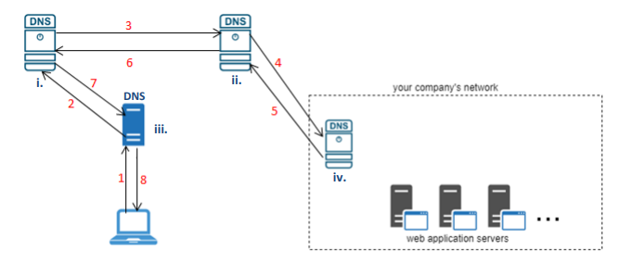

c. End-hosts labelling

1. __Root_________________________________________

2. __TLD_________________________________________

3. __Local_________________________________________

4. __Authoritative_________________________________________

d. In which server will the two RRs be inserted that you filled in the table above?

TLD

[2+3+4+1=10]

**Question 7:** What is the format of a resource record? Describe 4 different types of Resource Records, include their formats and explanation of elements in the format tuple.

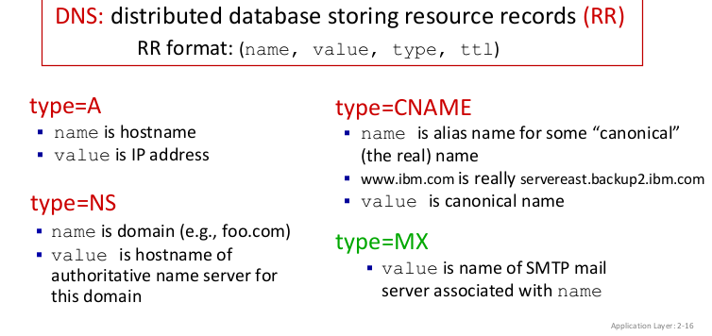

[1+1+1+1+1 = 5]

**Question 8:**

1. What is frame interleaving? How frame interleaving improves resource loading - discuss this part using a scenario based example to show your understanding.

Frame interleaving is a technique used in computer networking to improve resource loading and optimize data transmission over a network. It involves rearranging the order of transmitted frames or packets to achieve better utilization of available resources and enhance overall network performance.

Let's illustrate this with a scenario:

Imagine you're downloading a large file from a server over the internet. The file is divided into smaller units called frames or packets for transmission. Without frame interleaving, these frames would be sent sequentially, one after the other, from the server to your computer.

Now, consider a scenario where the network conditions are not ideal, and there's some level of latency or delay in transmitting data packets. If a packet encounters congestion or gets delayed due to network traffic, it can result in inefficient resource usage because subsequent packets have to wait in line before they can be transmitted.

Frame interleaving comes into play here to address this issue. Instead of sending the frames sequentially, the server interleaves or mixes them up before transmission. This means that frames from different parts of the file are interspersed within the data stream.

1. Discuss security concerns associated with cookies. Also, differentiate between persistent and session cookies.

Cookies can be exploited for tracking, data breaches, and session hijacking. Persistent cookies stay on a device even after closing the browser, potentially compromising privacy. Session cookies are temporary and vanish when the session ends, reducing long-term risks.

[2+3 = 5]

**Question 9:** Describe differences between SMTP (Simple Transfer Protocol) and IMAP (Internet Message Protocol). Explain how they work together in the context of email communication.

SMTP (Simple Mail Transfer Protocol) is used for sending outgoing emails between mail servers, while IMAP (Internet Message Access Protocol) is used by email clients to retrieve and manage emails from a remote server.

SMTP (Simple Mail Transfer Protocol) is typically considered a push protocol. IMAP (Internet Message Access Protocol), on the other hand, is generally regarded as a pull protocol.

Together, SMTP and IMAP facilitate the entire process of email communication, from sending messages to retrieving and managing them across different devices.

[2+3 = 5]

**Question 10:** Suppose user “XXXX”, with a Web-based e-mail account (such as Gmail or Outlook): sends a message to user “X+”, who accesses his mail from his mail server using POP3. Discuss how the message gets from the host of “XXXX” to the host of “X+”. Be sure to list the series of application-layer protocols that are used to move the message between the two hosts. Furthermore, discuss from a user’s perspective, what is the difference between the download-and-delete mode and the download-and-keep mode in POP3?

[3+2=5]

The scenario specifies that 5273 is the sender(source) who sends a message to 17 and 17 is the receiver(destination) who receives the message.

The flow of the message being sent from Alice to Bob is as follows:

* 5273 uses Web-based e-mail account
* HTTP protocol is used to send the message from 5273 browser to web-based mail server.
* From the Web-based mail server, the message of the 5273 is sent via SMTP (SMTP acts as 5273 client server) server
* The message is sent to 17’s mail server through the SMTP server (SMTP acts as 17’s server)
* From, 17's mail server, the message is transferred to 17 browser by using POP3 protocol in order to access the mail.

Therefore, here is the list of series of application-layer protocols which are used to transfer a message from 5273 to 17 are

5273 HTTP - Web based mail server - SMTP 17’s mail server - POP3 – 17

Download-and-Delete Mode: Emails are removed from the server after being downloaded. They are not accessible for future retrieval.

Download-and-Keep Mode: Emails remain on the server after being downloaded, allowing access from multiple devices.